Safety Lights Automation Based on Sensory Data (ACM:IA-I-RRL- PM-R-A)

John Mackenly Boniel Rollin (Student)

Bachelor of Science in Computer Engineering, College of Engineering, Architecture and Industrial Design, Bohol Island State University-Main Campus, [johnmackenly.rollin@bisu.edu.ph](mailto:johnmackenly.rollin@bisu.edu.ph)

MAX ANGELO DAPITILLA PERIN (INSTRUCTOR)

Faculty of Department of Computer Engineering, College of Engineering, Architecture and Industrial Design, Bohol Island State University-Main Campus, [maxangelo.perin@bisu.edu.ph](mailto:maxangelo.perin@bisu.edu.ph)

**Imaginative Abstract:** Way back million years ago the advancement of humans is imminent. From hunting-gathering-scavenging to using automated technology. It has never been easy for our species, but humans stayed resilient by imposing necessary protocols to increase the chances of survival. Today, automation plays a major part of human advancement and their safety. Safety protocols are used to ensure that individuals understand the hazards, risks and protective measures needed to perform over a certain procedure or work. Such protocols are not only implemented through a working environment, but also with technology. Automation is the creation and application of technologies to produce and deliver goods and services with minimal human intervention. Thus, increasing productivity while decreasing the chances of a person being exposed to danger. Sensor data is the output of a device that may be used to provide information or input to another system or to guide a process. This data detects and responds to sensory data. Sensory data is a type of input from the physical environment. With the integration of sensory data and automation, the researcher created the Safety Lights Automation Based on Sensory Data as a means of implementing safety through automating technology in our daily living. An Arduino microcontroller was used to make the system functional. Safety Lights Automation Based on Sensory Data works when sensory data from ultrasonic sensors are monitored and then mathematically converted into numbers which will be the basis for the LED bulbs to power and increase the brightness intensity and duration to function.

CCS CONCEPTS • Hardware • Emerging Technologies • Electromechanical Systems • Microelectromechanical Systems

Additional Keywords and Phrases: Arduino, Automation, LED, Microcontroller, Safety, Sensor, Sensor Data, Sensory Data

ACM Reference Format:

**John Mackenly Boniel Rollin**, **MAX ANGELO DAPITILLA PERIN**. 2022 **Safety Lights Automation Based on Sensory Data (ACM:IA-I-RRL- PM-R-A)**. In Research Project Presentation for Bachelor of Science in Computer Engineering 3 in CPE 323 – Microprocessor Systems S.Y. 2021-2022, 2nd Semester, Bohol Island State University-Main Campus, Tagbilaran City, Republic of the Philippines. ACM, New York, NY, USA

1. INTRODUCTION

Safety saves lives. Implementing safety is one way of ensuring one’s survivability. The most common safety measure we use is light. A safety light ensures that you are visible to others, drastically reducing the risk of being involved in an accident or dangerous situation, on land, in water or up in the air. A safety light is an urban necessity when out and about in the twilight or dark. When integrating with automation which is being used in a number of areas such as manufacturing, transport, utilities, defense, facilities, operations and lately, information technology. Automation is the creation and application of technologies to produce and deliver goods and services with minimal human intervention. We can create an automated safety light with implements safety and security with less human intervention. The implementation of automation technologies, techniques and processes improve the efficiency, reliability, and/or speed of many tasks that were previously performed by humans. The idea can’t be accomplished only with light and automation involved. In addition, Arduino sensor which is the ultrasonic sensor detects any objects with the sound it emits when bouncing it back. An ultrasonic Arduino sensor is a sensor that can measure distance. It emits an ultrasound at 40 000 Hz (40kHz) which travels through the air and if there is an object or obstacle on its path It will bounce back to the module. Considering the travel time and the speed of the sound you can calculate the distance. The device works when the ultrasonic sensor deters any objects and transmits it to the Arduino Uno board which it will control the functions when the safety lights will trigger.

1. REVIEW OF RELATED LITERATURE

There are several numbers of related literature with the application of Arduino and ultrasonic sensors in implementing safety. In [1] any system which is associated with human assistance needs to be portable, user-friendly and simple in structure. In a navigation system specially built to provide a walking assistance for visually impaired people, it is needed to map the surrounding in terms of a number of obstacles in the path of the person. In this paper, we are going to present a system which is wearable, portable and capable of detecting obstacles from surrounding. The system used ultrasonic sensors which provided a chirp signal.

As safety is the main concern which integrated with technology the authors in [2] designed and integrated Internet of Things (IoT) to an Arduino-based fire safety system that gives alert to fire-fighting facilities, authorities and building occupants to possibly prevent fire occurrences or reduce the probable damages it may cause. [2] When correctly maintained, operating fire safety systems are proven to be life saving devices that can get you out of a situation that would potentially turn into a tragedy. Sensory will be the main data collected. The authors in [3] agreed that sensory data can be fused and integrated. On the research, sensory data will be collected from the ultrasonic sensor which detects any objects based on the sound it emits. It will be controlled by the Arduino Uno microcontroller.

In [4], a workshop was conducted in 2013 shows analyzing sensory data on machine learning. With this proceeding, it proved that sensory data can be also analyze and integration to different programming which supports the project. But, [4] still remains a challenge for machine learning techniques to make sense of the ever-increasing "big data" streams, while sensor network deployments, leaving large footprints in bandwidth and energy consumption, still lack intelligent solutions for optimization.

1. PROPOSED METHODOLOGY

In this project, the sensory data from the ultrasonic sensors will be collected and monitored and then sent to the Arduino Uno board which controls the LED strip lights that will be used as the safety device. The code of this project is found on the important code.

* 1. Hardware Overview

**ARDUINO UNO:** The Uno is a microcontroller board based on the ATmega328P. It has 14 digital input/output pins (of which 6 can be used as PWM outputs), 6 analog inputs, a 16 MHz quartz crystal, a USB connection, a power jack, an ICSP header and a reset button. It contains everything needed to support the microcontroller; simply connect it to a computer with a USB cable or power it with an AC-to-DC adapter or battery to get started.

"Uno" means one in Italian and was chosen to mark the release of Arduino Software (IDE) 1.0. The Uno board and version 1.0 of Arduino Software (IDE) were the reference versions of Arduino, now evolved to newer releases. The Uno board is the first in a series of USB Arduino boards, and the reference model for the Arduino platform; for an extensive list of current, past or outdated boards see the Arduino index of boards.

**ULTRASONIC SENSOR- HC - SR04:** This is the HC-SR04 ultrasonic distance sensor. This economical sensor provides 2cm to 400cm of non-contact measurement functionality with a ranging accuracy that can reach up to 3mm. Each HC-SR04 module includes an ultrasonic transmitter, a receiver and a control circuit. There are only four pins that you need to worry about on the HC-SR04: VCC (Power), Trig (Trigger), Echo (Receive), and GND (Ground). You will find this sensor very easy to set up and use for your next range-finding project! This sensor has additional control circuitry that can prevent inconsistent "bouncy" data depending on the application.

Table 1: Lists of Components used in the study

|  |  |
| --- | --- |
| ULTRASONIC SENSOR HC-SR04 | Breadboard |
| Arduino UNO R3 |  |
| LED |  |
| Resistor (1k ohms) |  |
| Jumper Wires |  |

* 1. Components used

The Table 1 consists of the various components that will be used in making this project. One of the main components would be the Arduino UNO microcontroller, Ultrasonic Sensor HC-SR04, and the LCD. These components will serve as the core of the project. The other components are the breadboard, jumper wires, LED, connection pins, and resistors.

Circuit diagram of an arduino uno connected to an ultrasonic sensor. Connected through a breadboard with a resistor, LED, and jumper wires.

Figure 1: Circuit Diagram of the Ultrasonic Sensor with Arduino UNO

* 1. Circuit Diagram of the Ultrasonic Sensor with Arduino UNO

To start with the connection found on Figure 1, connect Arduino ground to Ultrasonic Sensor HC-SR04 ground. Connect Arduino second ground to first resistor end. Connect Arduino +5v to Ultrasonic Sensor HC-SR04 VCC. Connect Arduino pin 13 to Ultrasonic Sensor HC-SR04 trigger. Connect Arduino pin 12 to Ultrasonic Sensor HC-SR04 echo. Connect Arduino pin 11 to LED cathode. Lastly, connect LED anode to second end of resistor and cathode to Arduino pin 11. Figure 1, is the representation of what the researcher can achieve but limited to the simulator’s capacity.

* 1. Important Code

Ultrasonic Sensor with Arduino and LCD

#define trigPin 13

#define echoPin 12

#define led 11

void setup()

{

Serial.begin (9600);

pinMode(trigPin, OUTPUT);

pinMode(echoPin, INPUT);

pinMode(led, OUTPUT);

}

void loop()

{

long duration, distance;

digitalWrite(trigPin, LOW);

delayMicroseconds(2);

digitalWrite(trigPin, HIGH);

delayMicroseconds(10);

digitalWrite(trigPin, LOW);

duration = pulseIn(echoPin, HIGH);

distance = (duration/2) / 29.1;

if (distance < 10)

{ digitalWrite(led,HIGH);

}

else {

digitalWrite(led,LOW);

}

Serial.print(distance);

Serial.println(" cm");

delay(500);

}

REFERENCES

<bib id="bib1"><number>[1]</number>Ashish Patankar and Tooraj Nikoubin. 2016. Wearable System for Obstacle Detection and Human Assistance Using Ultrasonic Sensor Array. In Proceedings of the 7th International Conference on Computing Communication and Networking Technologies (ICCCNT '16). Association for Computing Machinery, New York, NY, USA, Article 14, 1–6. <https://doi.org/10.1145/2967878.2967893></bib>

<bib id="bib2"><number>[2]</number>Fernandino S. Perilla, George R. Villanueva, Napoleon M. Cacanindin, and Thelma D. Palaoag. 2018. Fire Safety and Alert System Using Arduino Sensors with IoT Integration. In Proceedings of the 2018 7th International Conference on Software and Computer Applications (ICSCA 2018). Association for Computing Machinery, New York, NY, USA, 199–203. <https://doi.org/10.1145/3185089.3185121></bib>

<bib id="bib3"><number>[3]</number>Otman A. Basir. 1993. Sensory data fusion and integration: a team consensus approach. Ph.D. Dissertation. University of Waterloo, CAN. Order Number: AAINN81037.</bib>

<bib id="bib4"><number>[4]</number>2013. Proceedings of Workshop on Machine Learning for Sensory Data Analysis. Association for Computing Machinery, New York, NY, USA.</bib>

APPENDICES

A screenshot of a github repository containing the contributions of the researcher



Figure 2: GitHub Repository contributions via (<https://github.com/MAKASA-LABORATORY/100-SSPTTMASSLBMC/commits?author=johnmackenly-rollin>)

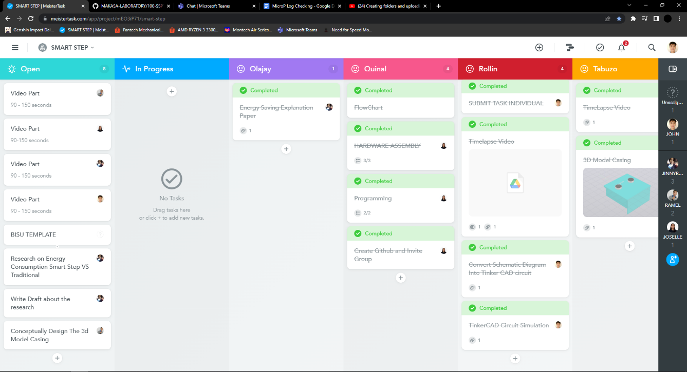

Figure 3: MeisterTask contributions via (<https://www.meistertask.com/app/project/mBO3iP71/smart-step>)